A Variety of Ways to Eat Healthy on a Budget

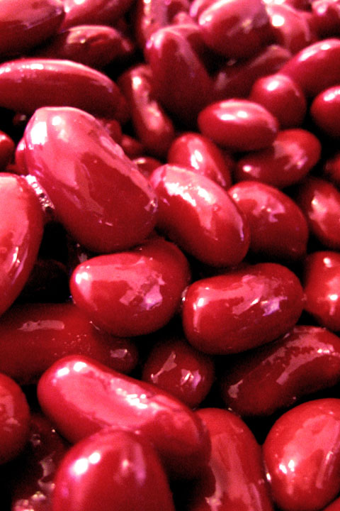
1. Beans
These kitchen staples offer variety and versatility. Dozens of varieties line grocery store shelves, allowing you to pick whichever appeals to you. Beans can also be added to infinite recipes, meaning you’re not limited to a single repetitive dish until the last bean is consumed. Consider making a bean soup with chopped carrots, celery, and potatoes, or try and make your own black bean burger. Feeling a little spicy? Use black-eyed peas and rice to make a stuffing for peppers…the possibilities are endless! To further add to the impressive resume of the bean, they are a great source of protein, folate, and fiber—good to know since meat can be super expensive and it’s also your perfect opportunity to try meatless Monday! For a 15-oz can of beans, expect to pay close to $0.75, while a one pound bag of dried beans will cost $1.50.
1 pound bag: $1.50
2. Oatmeal
Oatmeal (like what you see in the dried packets or in the bulk granola aisle in the grocery) is the perfect blank canvas for your dining needs. It can go sweet with fruit and brown sugar, or savory by mixing it into a hamburger for some sneaky health benefits. A good source of fiber and minerals that isn’t limited to breakfast like that sugary cereal at the store, oatmeal makes your money work for you all day. HC intern Hannah Orenstein uses oatmeal for a great start to the day. “Oatmeal is the perfect warm, hearty breakfast. Unlike most other cereals, it actually keeps me full for hours. I add banana slices and a few walnuts to plain oatmeal—so good!"
$0.12 per serving: $3.69/42oz canister
3. Sweet Potatoes
If you’re looking to step up the health benefits of your regular potato purchase, take a look at sweet potatoes. These oddly orange beauties are brimming with carotenoids, fiber, and vitamin A that fight free radicals and maintain healthy eyesight. Make sweet potato French fries, a baked potato, or even some cinnamon mashed sweet potatoes to change up the usual. Our HC writers have major love for sweet potatoes. Gabriela Szewcow heats hers up dessert style with marshmallows while Elana Altman uses a recipe from Mom: “Peel them, slice, and add just a tiny bit of olive oil. Sprinkle them with cinnamon, and then pop them in the oven. Sometimes I add apples or pecans to that recipe too!”
$0.50 per potato
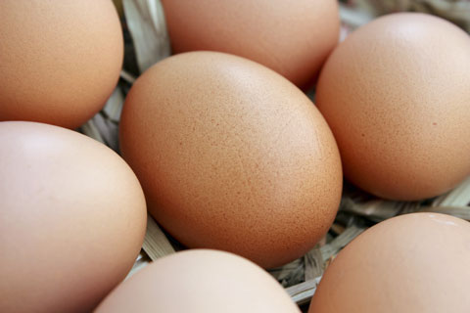
4. Eggs
Commonly referred to as the perfect protein, a single egg provides about six grams of protein, or 10-percent of the amount recommended for a 2,000-calorie diet. Eggs, like many of our top ten options, are multi-taskers in the kitchen. From a veggie omelet, to zucchini bread, you’ll likely use up all the eggs you purchase, saving you from money down the garbage disposal.
1 dozen eggs: $1.75
5. Spinach
I usually buy spinach instead of lettuce for my apartment for this reason: is cooked lettuce good for dinner? Not so much.
Spinach can be heated as a side dish, sautéed with meat, or even put in a smoothie. Lettuce, although the occasional menu bears an unfortunate warmed lettuce dish, is just not tasty when it tries to do the things that spinach can. Spinach is also more nutrient dense than lettuce, made up of fiber, vitamins A and C, and folate.
6-oz bag for $3.80
6. Brown Rice
From stir-fry to taco night, brown rice is a great kitchen staple. Think of it as an amped up sticky white rice since it still has the healthy outer layer (called the hull) of the grain. A single cup of brown rice tallies up to 88-percent of the manganese you need daily. Manganese, which is a mineral, helps produce energy and aids in maintenance of a top shape nervous system. Not only that, but a study by the American Journal of Clinical Nutrition found that women who ate whole grains instead of refined grains (white rice) were able to maintain a healthy body weight.
32-oz bag for $2.00
7. In-season fruits and veggies
Summer means that berries, tomatoes, and corn are in season, cheap, and therefore perfect for this list! In winter, citrus will be inexpensive, and in fall, apples will be a steal. Depending on the time of year, certain produce items come into season, and that season is the time to buy. Be on the lookout for sales at your grocery store, where they often discount in-season produce, or have two-for-one deals. If those pre-cut veggies and fruit happen to steal your eye remember this great tip sent in from reader Danielle Hartman, a senior at OSU:
“Even though it might be easier to grab vegetables that are pre-cut for you, it's a lot more affordable to buy the vegetables whole. Cut them when you get home and store them…for when you need a quick snack or are packing your lunch bag."
Examples of summer produce prices: 16-oz strawberries $2.50, 1 dozen ears of corn $2.00
8. Green tea bags
School is coming, so think zen! Green tea can be just what the doctor ordered after a hectic day on campus. The studies indicating green tea’s potential to fight cancer and heart disease are overwhelmingly positive. Other research has shown green tea and green tea extract can help combat obesity and lower LDL (unhealthy) cholesterol levels. By stocking up on tea bags to take to class, you’ll save yourself over $1.50 compared to picking up the pre-brewed variety en route. HC writer Katie Crandell uses green tea with lemonade for an Arnold Palmer alternative. Perfect for the tailgate!
20 count pack for $3.00 (15 cents each!)
9. Granola or store brand cereal
Granola can be a tricky health food. Don’t be fooled by the “health halo”! Read the ingredients list: if there’s lots of chocolate, sugar, and syrups, skip it and try another brand. But when you find the right fit minus the additives, stock up in bulk. For example, the first thing on Bear Naked’s ingredients list (and therefore what there is the largest amount of in the product) is whole grain oats, while the first ingredient on another brand is sweetened cranberries. Granolas that have whole grains or flax seeds can give you healthy fats and fit the bill for breakfast or a between class nosh.
Cereal can also be a great snack, as long as you don’t put the sugar coated kind in the basket. Scritchfield recommends toasted oats or shredded wheat (unsweetened), which can keep you full through Calculus class. By picking up the store brand, you’ll save yourself some cash without compromising on taste. Often the ingredient lists on name brand and store variety items are identical!

12-oz granola for between $3.00-5.00 16.4 oz box of store brand cereal $2.00
10. Salsa
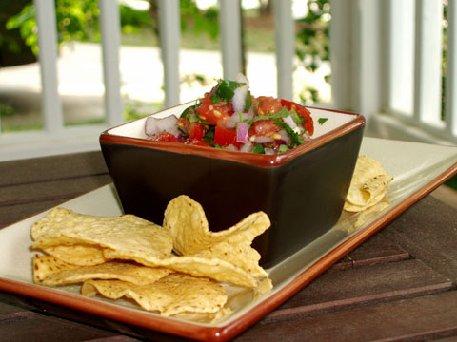
If the only time you’re picking up salsa is on Cinco de Mayo, you’re loco. A good salsa can have several veggies, and spicy heat packed into one jar with minimal calories. Newman’s Own makes it with all natural ingredients—no red dye or additives—marking it as a definite healthy pick. As for uses, try it as a topper for eggs, a dip for pitas, or a pre-made sauce for chicken. College can be ridiculously busy, and for that reason, a flavorful salsa is a blessing. HC writer Rachel Dozier has salsa as a top pick for snacks.
“There's nothing like salsa and some whole grain chips when you're looking for a tasty or healthy snack. It's great for football games or just for lounging around your apartment!”
15 oz jar of salsa for $2.00

