GRADUATE ASSISTANTSHIPS

Important Information: All steps need to be completed NO LATER THAN the 5th day after the beginning of the semester so it is important to this process early. Any appointments or requests submitted after that time may be denied.
https://www.stcloudstate.edu/graduatestudies/faculty-staff/grad-assistantships.aspx
Create & post position
- Determine funding source
- Create a position description
  - List GA supervisor and, if different,
  - List a second supervisor to be entered into student payroll to approve timesheets.
- Create or copy position description in GA system for current fiscal year
- Post position (methods can include Handshake, posting in department offices/bulletin boards/classrooms, etc, program listserv, or other communication systems your department may use)
- Determine eligible candidates
- Must have a declared masters major
- Must have an approved application & be admitted to SCSU
- Must hold a 3.0 GPA (exception can be made for new students who do not have an established GPA)
- Must be enrolled in 8 credits for semester they hold an assistantship
- Departments may have other requirements in addition to these such as: higher minimum GPA, only available to students in program, etc.
- Interview candidates
- Offer position to candidate

Begin hire steps in GA system & start hire paperwork
- Review approvers in GA system to ensure correct Chair, Responsible person for the budget, Dean/VP and any Proxy’s are up to date & correct.
- Create appointment in GA system
- Print hire letter, have candidate sign & return it to you, keep copy on file
- Have candidate accept the position in the GA system
- Create employment request in GA system & move to the next approver until it reaches Graduate Studies
- The hiring unit where the GA will be working will complete necessary hire paperwork with the student. ORIGINALS should be turned in to Business Services:
- I-9 (an SCSU employee must see identifying documents in person & collect copies)
- MN W-4
- Federal W4
- If student is international additional information may be needed (ie: copy of application that they have applied for an SSN, I-20, etc.)
- All hire paperwork must be turned in to Dan Swan in Business Services. He can accept electronic copies of all documents EXCEPT the I-9. If you have questions on any hire paperwork, especially requirements for international students, please contact him directly.
- If the GA is a new hire they must attend GA orientation

Final Approval from Graduate Studies
- Your GA will be reviewed by the School of Graduate Studies once the approver is listed as “Graduate Studies” At that time all eligibility and hire paperwork requirements will be reviewed to ensure the GA meets the conditions & obligations set forth by SCSU policies.

Other
- If a GA ends employment early you must notify Graduate Studies immediately
- GA processing does hold up financial aid awards so it is important to ensure you are meeting the deadline.

GA Timesheet Approval
- All graduate assistants will be required to complete a bi-weekly timesheet similar to student employees.
- A person must be designated as the supervisor to be entered into student payroll and approve the biweekly timesheets. This person will be responsible to ensure students have entered their hours accurately and submitted the timesheet each pay period.
- Payments for graduate assistants not submitting an accurate time sheet for each pay period will be delayed. Supervisors can enter hours or correct hours on behalf of the student.
- Academic year graduate assistants will have the option to select a “stipend plan” or a “true hours plan” for payment.
  - Stipend plan: students will enter the prescribed hours listed on the time card spreadsheet each week. The number of hours listed will be consistent each week and will be less than the required number of work hours, e.g. Students will enter 36.5 hours per pay period but will work 20 hours/week for a normal week or the number of hours listed for a holiday week (16 for Labor Day week) They will continue to submit payroll over winter break. This will ensure that their biweekly checks are fairly consistent and that they are paid over winter break.
  - True hours plan: Students will enter the actual expected hours listed per pay period. The hours will reflect the position expectations, e.g. 20 hours/week and the hours expected during a holiday week, e.g. 16 hours for Labor Day week. Checks will vary by pay period and there will be a break in pay for time not worked over winter break.
  - Graduate assistants must select a plan with the supervisor prior to the start of employment and must stay with this plan. It will not be an option to switch between plans.
  - Departments will note in the comments on the Approval Tab in the Requests section of the GA system if the graduate assistant is Stipend Plan or True Hours plan. Enter the information and “save comment”
- Single semester graduate assistants must all be on the True Hours plan.
- A full-time GA will work 330 hours each semester to earn the $9253.20. And a part-time GA will work 165 hours each semester to earn the $4626.60. The hours to enter for each pay period for students beginning convocation week (payroll begins 8/16) or 8/21 are included on the spreadsheets. The stipend plan and the true hours plan reflect the number of hours the student should enter for each week and the total number of hours that should be approved each pay period.
- Graduate assistants will need to make up hours missed to earn the allocated amount. Hours can be made up across pay periods. The total entered per pay period cannot exceed 40 hours. Students can elect not to make up hours and not be paid. They will subtract the hours missed from the total for the pay period and enter the reduced number for the pay period. This will result in a decrease in pay for the pay period and overall.
- Hiring units are responsible to ensure graduate assistants are entering their hours accurately and not exceeding the number of hours allowed. Any overpayment will be billed to the department and they will be responsible for having the student work or working with student payroll to retrieve the over-paid funds from the student.
- Graduate assistants hired after the 10th day of the semester will need to have the stipend prorated or the department will need to 1) identify if students will be making up missed hours over winter break or spring break or 2) extend the contract in May.

2023-24 Holiday and Break Dates
Fall 2023 | Spring 2024
Labor Day, Sept. 4 | Martin Luther King Jr. Day, Jan. 15
Veteran's Day (observed), Nov. 10 | Spring Break, March 4-8
Thanksgiving Break, Nov. 20-24 | University Provost Summit, April 16
Winter Break, Dec. 18 - Jan. 2

Resources
- GA Hiring Guide – step by step instructions for entering appointments & employment requests in the GA hire system GA Hiring Training Manual
- GA Handbook – policies related to assistantships GA Handbook
- If you have any issues, questions, concerns, suggestions please contact:
  - Melanie Guentzel mjguentzel@stcloudstate.edu or 308-2194
  - Candy Swenson cmswenson1@stcloudstate.edu or 308-4793
An appointment can also be scheduled (outlook invite, zoom, Teams, Bookings)
- Payroll https://www.stcloudstate.edu/businessservices/accounting/payroll/default.aspx
- Supervisor Timesheet Approval Information Minnesota State Student Payroll Supervisor Train the Trainer Guide (PDF)

Timesheet Data Entry by Plan and Start Date
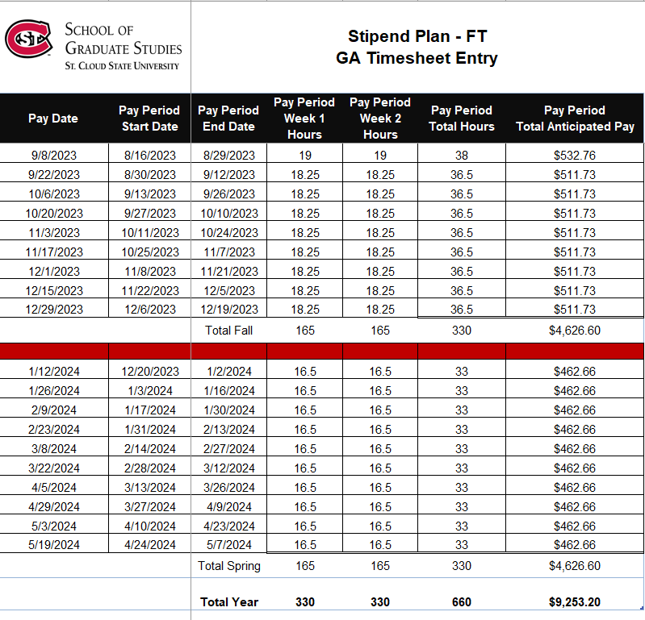
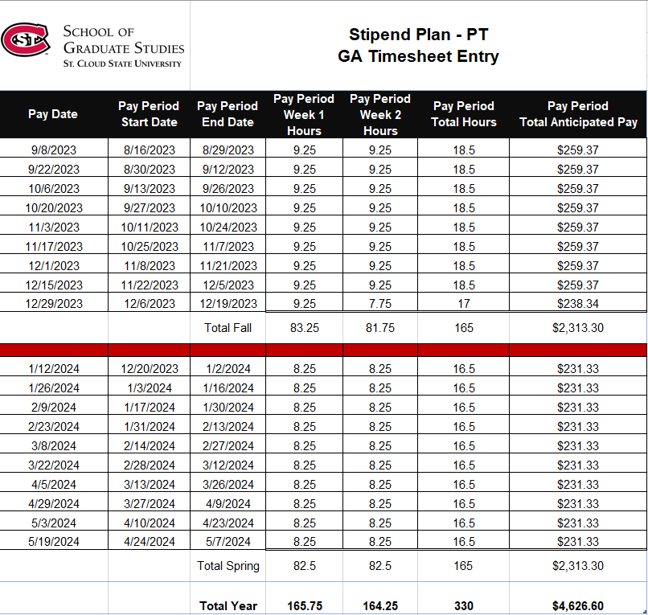
Stipend Plan – Start date 8/14-8/16

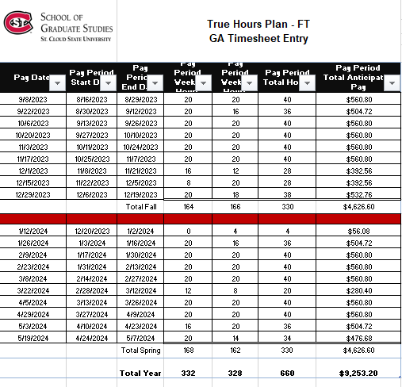
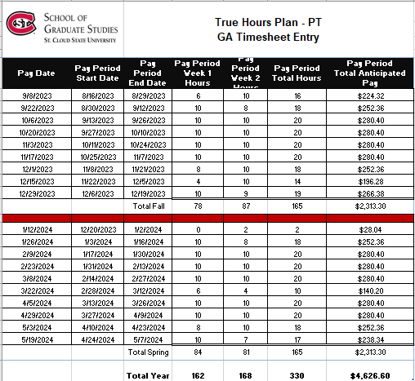
True Hours Plan – Start date 8/14-8/16

Timesheet Data Entry by Plan and Start Date
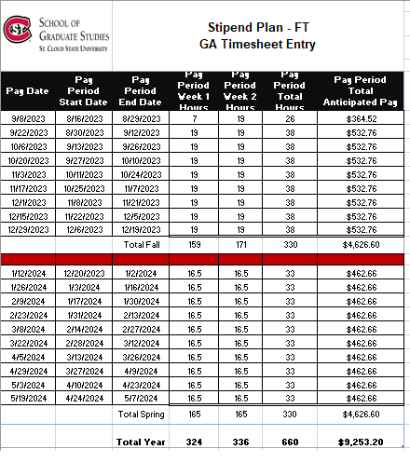
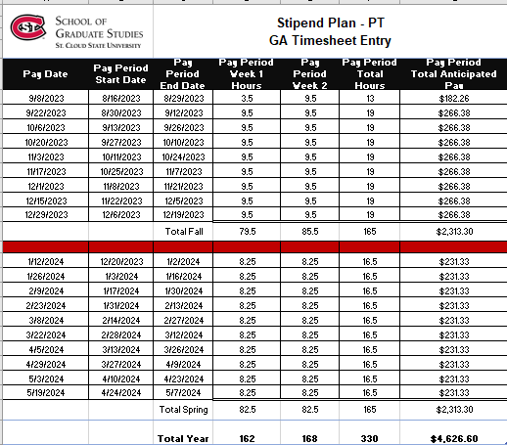
Stipend Plan: Start date 8/21

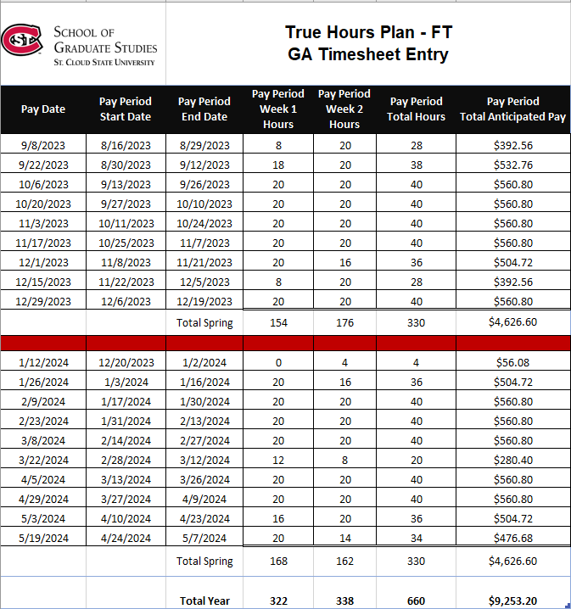
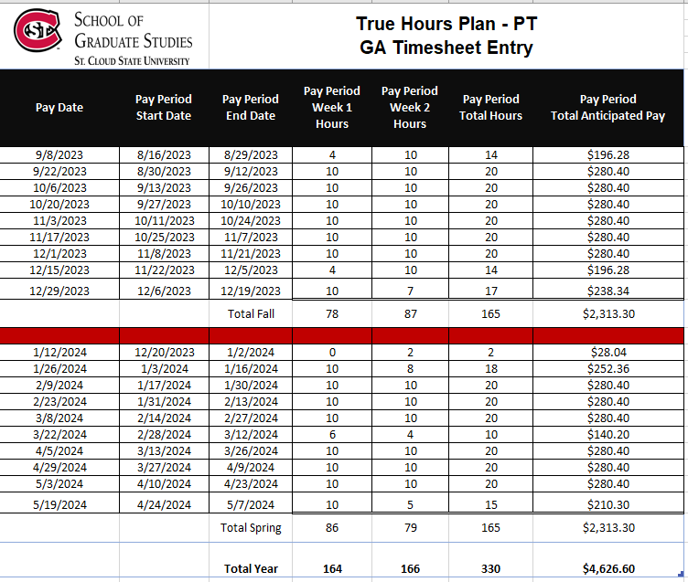
True Hours Plan: Start date 8/21

