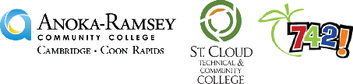

Noyce Husky STEM Teacher Scholar Interest Form

Please complete and return this form to gescobedo@stcloudstate.edu and mhanzsek@stcloudstate.edu

The benefits of the NOYCE scholarship are:
- Full cost of attendance (tuition, fees, room/board, etc.) scholarship for your last four semesters at SCSU
- Earn $1500 per semester and serve as a leader in the Learning Assistant Program at ARCC, SCTCC, or SCSU
- Serve in under-represented schools
- Make a tangible and practical difference in the lives of students

Name:

What school are you currently attending:
Campus Email:

Personal Email (if any):

Personal Cell Phone:

Do you give us permission to text you? Yes No
Major:

Minor:

Who is your current academic/program advisor?

Possible transfer date to SCSU:

Please complete and return this form to gescobedo@stcloudstate.edu and mhanzsek@stcloudstate.edu

